**Chapter 1**

**INTRODUCTION**

Paying Guest Review System mainly focuses on providing an exclusive website for people to view details of Paying Guest Rooms available or submit a review of a Paying Guest Room. This project is developed using HTML, CSS, Javascript and PHP. This project provides a platform for users to add their reviews or view the details of a PG.

**1.1 Project Description**

**1.1.1 Problem Statement**

As per our observation people find it difficult to look for a Paying Guest Room. In-order to overcome this problem we have come up with website where user can look for the PG as per their needs. Users can also help other users by giving their valuable feedback.

**1.1.2 Purpose**

The purpose of Paying Guest Reviews is to make it easier for people to find a paying guest room as per their needs.

**1.1.2 Project Scope**

The Scope of this project is to make all PG details available at one place. This would benefit users to find the paying guest room as per their needs without spending their time looking for PGs manually.

**1.2 HTML**

HTML is a computer language devised to allow website creation. These websites can then be viewed by anyone else connected to the Internet. It is relatively easy to learn, with the basics being accessible to most people in one sitting; and quite powerful in what it allows you to create. It is constantly undergoing revision and evolution to meet the demands and requirements of the growing Internet audience under the direction of the W3C, the organization charged with designing and maintaining the language. The definition of HTML is HyperText Markup Language. HyperText is the method by

which you move around on the web by clicking on special text called hyperlinks

which bring you to the next page. Markup is what HTML tags do to the text inside them. They mark it as a certain type of text.

**1.3 PHP**

PHP started out as a small open source project that evolved as more and more people found out how useful it was. Rasmus Lerdorf unleashed the first version of PHP way back in 1994.

* PHP is a recursive acronym for "PHP: Hypertext Preprocessor".
* PHP is a server side scripting language that is embedded in HTML. It is used to manage dynamic content, databases, session tracking, even build entire e-commerce sites.
* It is integrated with a number of popular databases, including MySQL, Oracle, Sybase, Informix, and Microsoft SQL Server.
* PHP is pleasingly zippy in its execution, especially when compiled as an Apache module on the Unix side. The MySQL server, once started, executes even very complex queries with huge result sets in record-setting time.
* PHP supports a large number of major protocols such as POP3, IMAP, and LDAP. PHP4 added support for Java and distributed object architectures (COM and CORBA), making n-tier development a possibility for the first time. PHP Syntax is C-Like.

**1.4 DATABASE**

A Database is a collection of information that is organized so that it can easily be accessed, managed and updated. In one view, database can be classified according to the type of content: bibliographic, full-text, numeric, and images.Database software systems are programmed in SQL, and examples include Microsoft SQL Servers, MYSQL, Oracle SAP HANA and FoxPro.

A DBMS system is also required to protect the integrity of data and provide its security.A database management system is a system software for creating and managing databases. This system provides users and programmers with a systematic way to create, retrieve, update and manage data.

**1.5 XAMPP**

The acronym XAMPP refers to a set of free applications, Combined with Microsoft windows, which is commonly used in web service environments. The XAMPP stack provides developers with the four key elements of a Web server. An operating system, database, Web server, and web scripting softwares. The Combined usage of these programs is called a server stack, Microsoft Windows is an operating system, Apache is the web server, MYSQL handles the database components, While PHP, Python or Perl represents the dynamic scripting languages.

**1.6 WEB BROWSER**

**Google Chrome** is a free web browser from google which we are using here. With its clean design and advanced features, chrome has quickly become one of the most popular web browser world wide.

**Chapter 2**

**REQUIREMENT SPECIFICATION**

A software requirements specification (SRS) is a comprehensive description of the intended purpose and environment for software under development. The SRS fully describes what the software will do and how it will be expected to perform. Software requirements specification establishes the basis for an agreement between customers and shopkeepers on what the software product is to do as well as what is not expected to do. It should also provide a realistic basis for estimating product costs, risks, and schedules. Software requirement specification prevents software project from failure

**2.1 Hardware requirement**

* i3 (Processor).
* 2gb Ram
* 512 KB Cache Memory
* Hard disk 10 GB
* Microsoft Compatible 101 or more Keyboard

**2.2 Software Requirement**

|  |  |
| --- | --- |
| Operating System | Windows OS, Ubuntu |
| Windows Technology | PHP |
| Front-End | HTML,CSS,JAVASCRIPT |
| Back-End | MySQL |
| Web Server | XAMPP SERVER |

**2.3 Functional Requirements**

A functional requirement document defines the functionality of a system or one of its subsystems. It also depends upon the type of software, expected users and the type of system

where the software is used. Functional user requirements may be high-level statements of what the system should do but functional system requirements should also describe clearly about the system services in detail. The following are the key fields, which should be part of the functional requirements specifications document:

* Scope
* Business Processes
* Data and Integration
* Security Requirements
* Performance

**2.4 Non-Functional Requirements**

Non-functional requirements are requirements that are not directly concerned with the specific functions delivered by the system. They may relate to emergent system properties such as reliability, response time and store occupancy. Alternatively, they may define constraints on the system such as the capabilities of I/O devices and the data representations used in system interfaces. The plan for implementing functional requirements is detailed in the system design. The plan for implementing non-functional requirements is detailed in the system architecture.

The Non-functional Requirements of the project are as follows:

• This web Application is designed in such a way to that users can view the details of various Paying Guest Rooms.

• This Web Application also is a platform for users to submit their reviews and feedback about Paying Guest Room.

**Chapter 3**

**ANALYSIS AND DESIGN**

The design phase seeks to detailed specifications that emphasize the physical solution to the project.

In software engineering, a class diagram in the Unified Modeling Language (UML) is a type of static structure diagram that describes the structure of a system by showing the system's classes, their attributes, operations (or methods), and the relationships among objects.

These are the modules present in College OLX Management System:

* **REGISTRATION / LOGIN MODULE.**
* User can create his account who want to write a review on this platform.
* By logging in as a user one can write a review or view PG details.

#### **VIEW MODULE**

#### User can view the PG details.

#### **WRITE REVIEW MODULE**

#### User can write the review about the PG.

**3.1 FLOW CHART**

A flowchart is a type of diagram that represents an algorithm, workflow or process. The flowchart shows the steps as boxes of various kinds, and their order by connecting the boxes with arrows. This diagrammatic representation illustrates a solution model to a given problem. Flowcharts are used in analyzing, designing, documenting or managing a process or program in

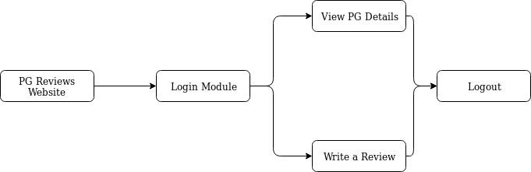

Fig 3.1.1 Flow Chart of PG Reviews Website.

**Chapter 4**

**IMPLEMENTATION**

Implementation is the carrying out, execution, or practice of a plan, a method, or any design, idea, model, specification, standard or policy for doing something. As such, implementation is the action that must follow any preliminary thinking in order for something to actually happen. It is the process, which tells the reliability, efficiency and flexibility of the design system. Reliability means, how much the user is expecting from the system. Flexibility tells how much the user is comfortable and has additional facilities with the system. Implementation gives the detailed view of the project and describes the pseudo code. Implementation is the stage where the theoretical design is turned into a working system. The most crucial stage in achieving a new successful system and in giving confidence on the new system for the users that it will work efficiently and effectively. It involves careful planning, investigation of the current system and its constraints on implementation, design of methods to achieve the changeover and an evaluation of change over methods a part from planning. Two major tasks of preparing the implementation are education and training of the users and testing of the system. The more complex the system being implemented, the more involved will be the systems analysis and design effort required just for implementation. The implementation phase comprises of several activities. The required hardware and software acquisition is carried out. The system may require some software to be developed. For this, programs are written and tested. The user then changes over to his new fully tested system and the old system is discontinued.

**4.1 CODE SNIPPETS**

The following images are the some of the sample code snippets which we used to perform database operation in our project.

**4.1.1 Login Module**

<?php

include('config.php');

$username = $_POST['username'];

$passw = $_POST['password'];

$query = "SELECT * FROM users WHERE name='$username' and password = '$passw'";

$result = $db->query($query);

if($result->num_rows == 1){

session_start();

$row = $result->fetch_assoc();

$_SESSION['username'] = $row['name'];

$_SESSION['uid'] = $row['uid'];

echo "<script>location.href='review.php'</script>";

}else{

echo "<script>$('#exampleModal').modal('show')</script>";

}

?>

**4.1.2 View Module**

<div class="container"style="padding-top:5rem; margin-bottom:50px;">

<div class="row card-holder" id="area" style="min-height:45vh">

<?php

include('config.php');

$query = "SELECT * FROM pg";

$result = $db->query($query);

while($row = $result->fetch_assoc()) {

echo '<div class="col-md-4" data-id="${doc.id}" onclick="location.href=\'showDetails.php?pid='.$row['pid'].' \'">';

echo '<div class="e-card">';

echo '<div class="e-card-top" style="background-image:url(./img/'.rand(1,5).'.jpg)">';

echo '</div>';

echo '<div class="e-card-bottom">';

echo '<h5 class="strong">'.$row['pname'].'</h5>';

echo '<p>';

if($row['foodType'] == 'veg'){

echo '<img src="./img/veg.png" width="15px">';

}else{

echo '<img src="./img/nveg.png" width="15px">';

}

echo '&nbsp;&nbsp;&nbsp;&nbsp;';

if($row['targetGender'] == 'M'){

echo 'For men';

}else if($row['targetGender'] == 'F'){

echo 'For women';

}else{

echo 'For men and women';

}

echo '</p>';

echo '</div>';

echo '</div>';

echo '</div>';

}

?>

</div>

</div>

**4.1.3 Review Form**

<form action="submitreview.php" method="POST">

<div style="position:relative;margin-top:20px">

<input type="radio" name="stars" id="star-null" value=0 style="opacity:0" />

<input type="radio" name="stars" id="star-1" value=1 style="opacity:0"/>

<input type="radio" name="stars" id="star-2" value=2 style="opacity:0"/>

<input type="radio" name="stars" id="star-3" value=3 style="opacity:0"/>

<input type="radio" name="stars" id="star-4" value=4 style="opacity:0"/>

<input type="radio" name="stars" id="star-5" value=5 style="opacity:0"/>

<section>

<label for="star-1">

<i class="fas fa-star fa-2x" style="color:rgba(255,255,255,0.6)" id="s1"></i>

</label>

<label for="star-2">

<i class="fas fa-star fa-2x" style="color:rgba(255,255,255,0.6)" id="s2"></i>

</label>

<label for="star-3">

<i class="fas fa-star fa-2x" style="color:rgba(255,255,255,0.6)" id="s3"></i>

</label>

<label for="star-4">

<i class="fas fa-star fa-2x" style="color:rgba(255,255,255,0.6)" id="s4"></i>

</label>

<label for="star-5">

<i class="fas fa-star fa-2x" style="color:rgba(255,255,255,0.6)" id="s5"></i>

</label>

</section>

</div>

<div class="form-group mt-5">

<textarea style="height:300px; width:500px; font-size:2rem; z-index:1000" name="comment" class="form-control" placeholder="How was your experience at this PG?"></textarea>

</div>

<input type="hidden" name="pid" value="<?php echo $_GET['pid'] ?>">

<center> <input type="submit" class="btn btn-shade no-bkg" value="Submit Review"></center>

</form>

**4.1.4 Submit Review**

<?php

session_start();

include('config.php');

$stars = $_POST['stars'];

$comment = $_POST['comment'];

$uid = $_SESSION['uid'];

$pid = $_POST['pid'];

$query = "INSERT INTO reviews(comment, stars, pid, uid) VALUES ('$comment', '$stars', '$pid', '$uid')";

$result = $db->query($query);

echo "<script>$('#exampleModal').modal('show')</script>";

?>

**Chapter 5**

**RESULTS AND SNAPSHOTS**

In this chapter the results of the project are described. The Snapshots of the project showing various functionalities like login, view, and write review are showcased.



Figure 5.1 Main Page

Landing Page of PG Reviews Website.

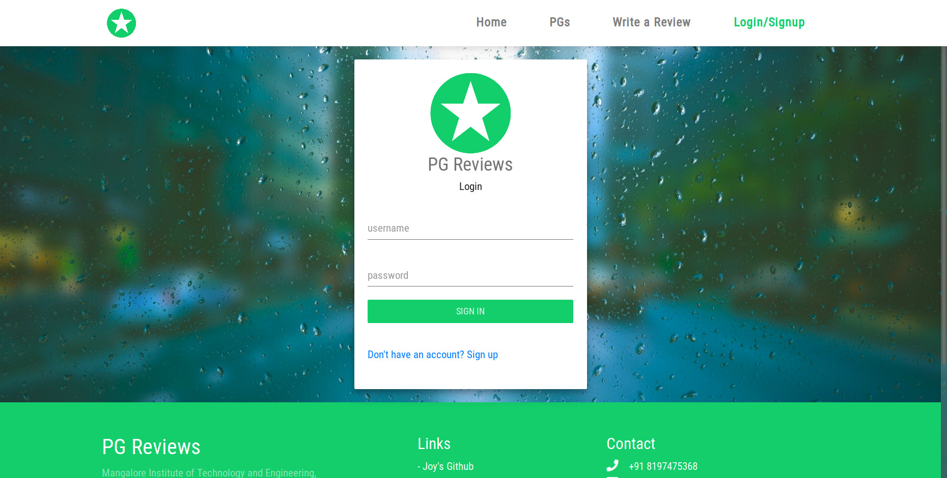 Figure 5.2 Login Page

Login page where users can login to their account and add their reviews.

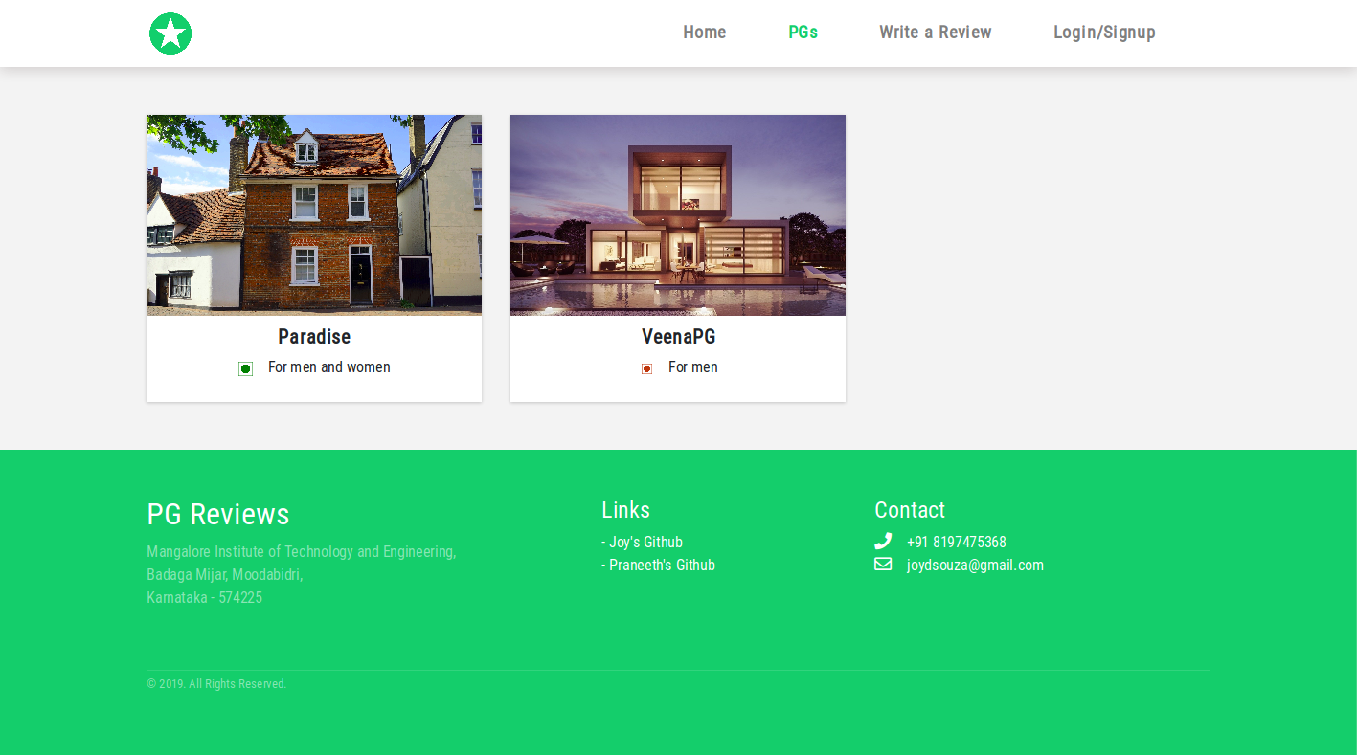

Figure 5.3 View PGs Page

View PGs Page where users can see the details of various PGs.

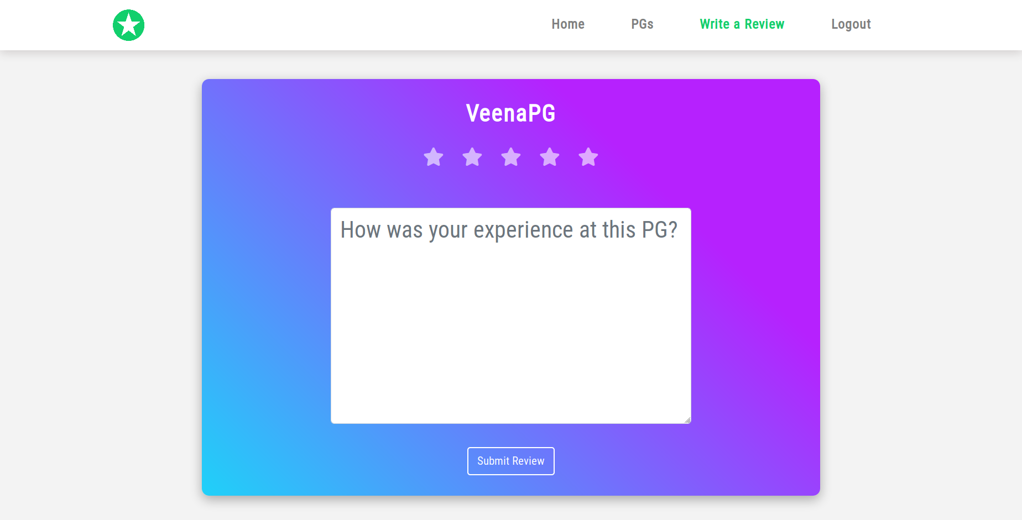Figure 5.4 PG Review Form.

PG Reviews Page where logged in users can submit their reviews.

**CHAPTER 6**

**CONCLUSION**

PG Reviews Website is a platform for reviewing Paying Guest Rooms. This website is specially designed to make it easier to for people to find a Paying Guest Room that suits their needs.

**REFERENCES**

[1] HTML Tutorials W3Schools ([www.w3schools.com/html](http://www.w3schools.com/html)).

[2] PHP Tutorials W3Schools ([www.w3schools.com/html](http://www.w3schools.com/html)).

[3] Material Login Form (www.codepen.io).

[4] Randy Collolly, Ricardo Hoar “Fundamentals of Web Development”, 1st Edition,

Pearson education India.